**Identity**

A woman's identity is often shaped by expectations she never agreed to. She is taught from birth how to behave, how to dress, and how to live within the boundaries that society has established for her. Her worth is too often tied to her appearance - light skin is praised, dark skin is a shame; modest dressing is virtuous, provocative styling is scandalous. Strength is defiance, ambition is arrogance, and independence is rebellion. Even her micro emotions are scrutinized - if she is too nurturing, she is weak, if she speaks out too much, she is difficult.

These prejudices follow her into every stage of life. A girl in school is taught to sit "properly" while boys fidget. A young professional woman is questioned for her competence, routinely passed over for promotion, or dismissed with assumptions that she'll eventually leave to "concentrate on family." When she does assert herself, she sounds bossy; when she says nothing, she lacks leadership skills. If she prioritizes her work, she is neglecting her family; if she stays at home with her children, she lacks ambition. Expectations contradict each other, leaving her in a constant battle to prove herself in ways men rarely have to.

Even within her own home, she is habitually expected to make sacrifices without question. Her success follows her duty to nurture, to negotiate, to sacrifice. If a marriage fails, she is to blame. If a home fails, she is the one who is guilty. Personal choices are never personal - everything is measured against an invisible rulebook written by tradition and policed by society.

Women are always in a double bind. If they do fit in, they're labeled weak or boring; if they step out, they're labeled aggressive or careless. A woman who opts to remain single is pitied, and a woman who marries is told to have children. If she has children and a career, she's asked how she manages to do it all, as if the weight of balance is hers to bear. If she opts to be a stay-at-home mother, her work is undervalued, as if raising the next generation is less significant than success in the boardroom.

Beyond expectations, women face deeply rooted biases in the workforce. Men are assumed competent until they prove otherwise; women must constantly prove themselves from the start. Male business executives are assertive, but female business executives are frequently described as aggressive. Women entrepreneurs encounter challenges in being funded, with questions about their commitment to business, while their male counterparts are encouraged for being risk-takers. The gender pay gap is an undisputed reality, not a result of insufficient competencies on the part of women, but because their work is devalued by society.

A woman's autonomy is limited in most societies not just by expectations but also by institutional barriers. In some societies, young girls are denied education since it is not deemed a requirement for their "future roles." Women are discouraged from studying STEM subjects or leadership roles because they are "not cut out for it." Even in liberal societies, workplace policies rarely take into account maternity leaves, child care, or equal career trajectories, forcing women to make choices that they should not have to make.

Looks are at the heart of how women are perceived by the world. The beauty industry is a multi-billion-dollar industry that thrives on the insecurities it helps generate, making women feel that they must constantly enhance, modify, or conceal something about themselves to be acceptable. Fairness creams, dieting products, anti-aging products—each one reinforcing the message that a woman, as she is, is not good enough. Women are judged based on their looks before they are admired for what they do. If a woman dresses up, she is trying too hard; if she dresses down, she is not looking after herself. The judgment is relentless, and the expectation is ever-changing.

Other than profession and appearance, every decision women make is scrutinized endlessly. Reproductive rights are one area where women continue to struggle to assert control over their own bodies. Access to contraception, abortion, or even basic healthcare is denied in most places on the basis of outdated laws and social stigma. That a woman must justify her decision to have children, not have children, or delay having them is simply another indication of control over her.

Even safety is a privilege that is not accorded to women. Walking at night alone, taking public transport, visiting unfamiliar places—all come with risks that men rarely have to consider. Women are instructed to "stay safe" rather than society addressing the cause of violence against women. Victim-blaming is common as well, in which a woman is asked what she was doing rather than her perpetrator being questioned. The possibility of harassment, violence, or worse is a constant in women's lives, dictating where they go, how they dress, and how they navigate the world.

Societal expectations of marriage and family also dictate a woman's life. Marriage is not just a choice but an expectation in most societies. Women are often defined by their marriage status, as if their value is hinged on whether or not they are someone's wife and mother. Divorce is still highly stigmatized, even when staying in a marriage is unsafe. Women who choose to leave are typically blamed, while men who do the same are rarely criticized. Even in marriage, "submission" is typically romanticized, with the suggestion that a woman must adjust and accommodate, regardless of her happiness or well-being.

Despite all of these challenges, women continue to redefine independent, successful, and free. They are taking up space in politics, science, business, and the arts. They are leading movements, breaking down barriers, and challenging norms that have existed for centuries. The progress is real, but the fight is far from over.

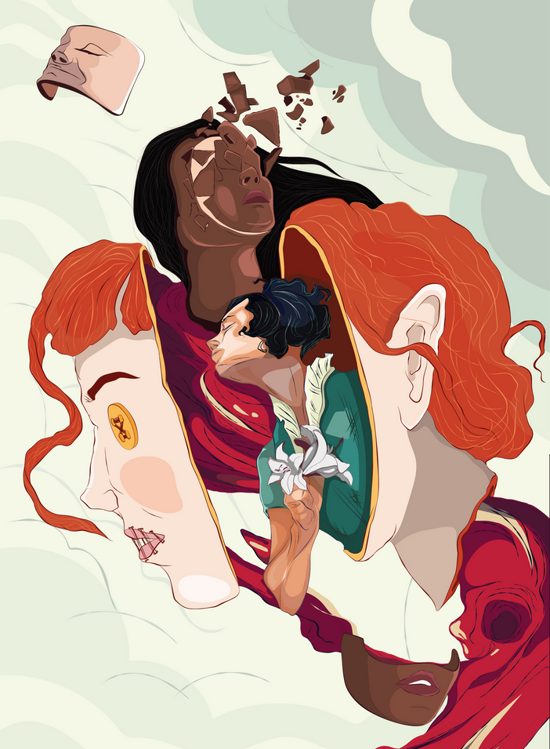

Back in 2022, I made this digital illustration to discuss the topic at hand. It was drawn as a tribute for my elder sister for Women’s Day. I tried to showcase multiple issues with our society where women are born into predefined roles and stereotypes. For example, women are expected to keep their hair short or wear feminine garments, women are expected to put on various fairness enhancing creams to lighten their skin ton and many more. The center piece of the art is based on a ragdoll because women in various places are not allowed to have their own views or voice.

The problems listed above can be said about any gender however in majority of situations women get the short end of the stick, after all, women required an internationally recognized day to bring forward issues such as these. This day was never about honoring women, rather recognizing the contributions they can have when they can overcome these issues.

The reality that an internationally celebrated day for women exists is not something to be celebrated but remembered - a reminder of the battles still being fought, the voices still being silenced, and the work that still remains unseen. Things will not change when women fit the mold of society, but when society's mold no longer fits - when identity is fashioned by choice, not prejudice.